assignment3.R

Suraj

Fri May 03 15:52:56 2019

# Airpassengers dataset  
library(forecast)

## Warning: package 'forecast' was built under R version 3.5.3

library(timeSeries)

## Warning: package 'timeSeries' was built under R version 3.5.3

## Loading required package: timeDate

data("AirPassengers")  
View(AirPassengers)  
plot(AirPassengers)  
  
class(AirPassengers)

## [1] "ts"

start(AirPassengers)

## [1] 1949 1

end(AirPassengers)

## [1] 1960 12

frequency(AirPassengers)

## [1] 12

summary(AirPassengers)

## Min. 1st Qu. Median Mean 3rd Qu. Max.   
## 104.0 180.0 265.5 280.3 360.5 622.0

plot(AirPassengers)  
abline(reg=lm(AirPassengers~time(AirPassengers)))

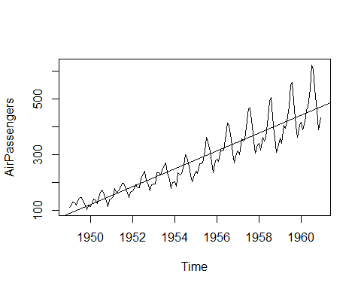

cycle(AirPassengers)

## Jan Feb Mar Apr May Jun Jul Aug Sep Oct Nov Dec  
## 1949 1 2 3 4 5 6 7 8 9 10 11 12  
## 1950 1 2 3 4 5 6 7 8 9 10 11 12  
## 1951 1 2 3 4 5 6 7 8 9 10 11 12  
## 1952 1 2 3 4 5 6 7 8 9 10 11 12  
## 1953 1 2 3 4 5 6 7 8 9 10 11 12  
## 1954 1 2 3 4 5 6 7 8 9 10 11 12  
## 1955 1 2 3 4 5 6 7 8 9 10 11 12  
## 1956 1 2 3 4 5 6 7 8 9 10 11 12  
## 1957 1 2 3 4 5 6 7 8 9 10 11 12  
## 1958 1 2 3 4 5 6 7 8 9 10 11 12  
## 1959 1 2 3 4 5 6 7 8 9 10 11 12  
## 1960 1 2 3 4 5 6 7 8 9 10 11 12

plot(aggregate(AirPassengers,FUN=mean))

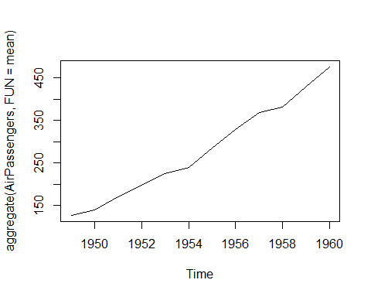

boxplot(AirPassengers~cycle(AirPassengers))

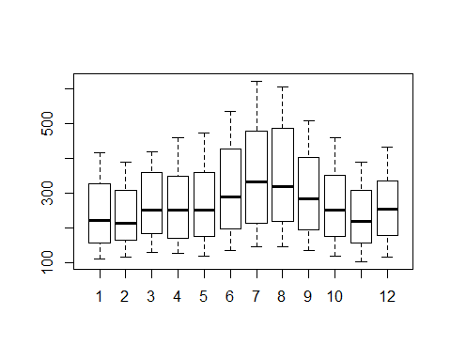

acf(log(AirPassengers))

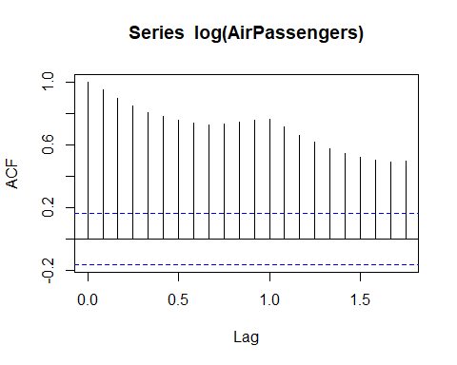

acf(diff(log(AirPassengers)))

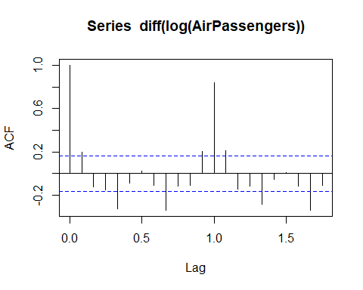

pacf(diff(log(AirPassengers)))

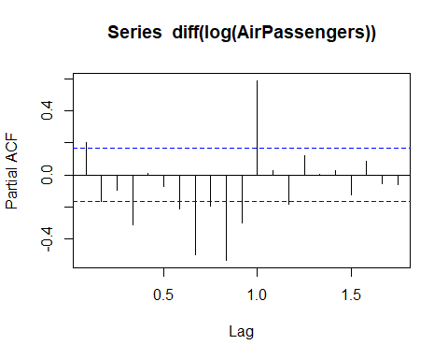

fit <- arima(log(AirPassengers), c(0, 1, 1),  
 seasonal = list(order = c(0, 1, 1), period = 12))  
pred <- predict(fit, n.ahead = 10*12)  
ts.plot(AirPassengers,2.718^pred$pred, log = "y", lty = c(1,3))

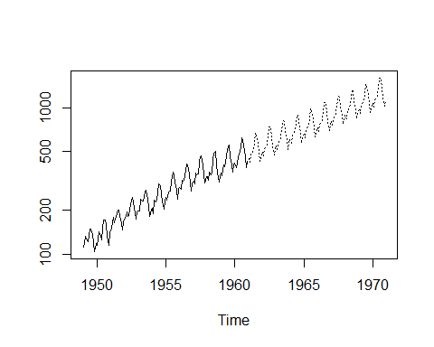

h1 <- HoltWinters(AirPassengers, alpha="0.5", beta=0.3, gamma=0.2, seasonal = "multiplicative")  
plot(h1)

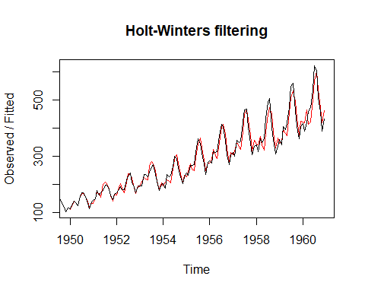

h2 <- HoltWinters(AirPassengers, alpha="0.5", beta=0.3, gamma=0.2, seasonal = "additive")  
plot(h2)

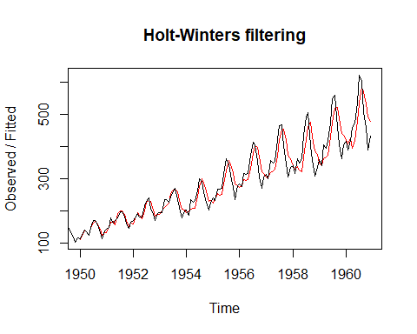

h3 <- HoltWinters(AirPassengers, alpha="0.5", beta=0.3, gamma=NULL, seasonal = "multiplicative")  
plot(h3)

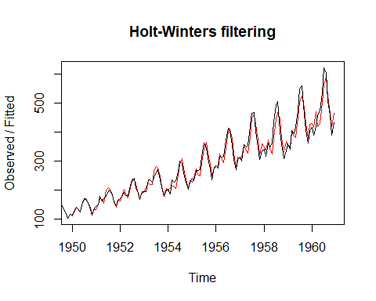

h3 <- HoltWinters(AirPassengers, alpha="0.5", beta=0.3, gamma=NULL, seasonal = "additive")  
plot(h3)

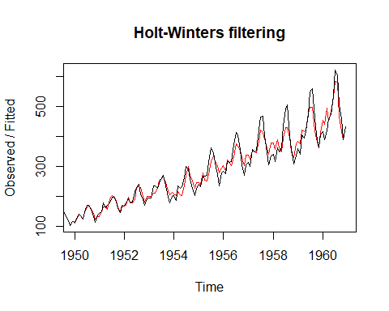

h4 <- HoltWinters(AirPassengers, alpha="0.5", beta=NULL, gamma=NULL, seasonal = "additive")  
plot(h4)

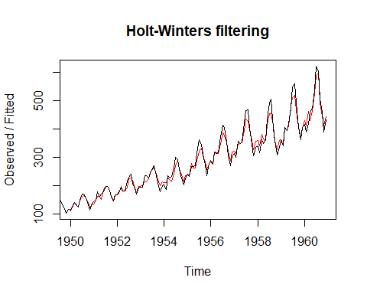

predict(h4)

## Jan  
## 1961 455.7067

predict(h4, n.ahead = 12)

## Jan Feb Mar Apr May Jun Jul  
## 1961 455.7067 439.3487 488.9996 516.4954 524.6679 582.4770 652.6906  
## Aug Sep Oct Nov Dec  
## 1961 631.9450 527.6073 473.0967 412.6361 460.1758

predict(h1, n.ahead = 12)

## Jan Feb Mar Apr May Jun Jul  
## 1961 454.0631 448.3313 517.3658 506.3646 491.2708 543.5584 586.9933  
## Aug Sep Oct Nov Dec  
## 1961 566.7703 485.9691 429.5541 376.6006 426.5524

predict(h1, n.ahead = 120)

## Jan Feb Mar Apr May Jun Jul  
## 1961 454.0631 448.3313 517.3658 506.3646 491.2708 543.5584 586.9933  
## 1962 435.7003 430.1390 496.3010 485.6775 471.1318 521.1996 562.7647  
## 1963 417.3375 411.9467 475.2362 464.9904 450.9928 498.8407 538.5362  
## 1964 398.9747 393.7544 454.1714 444.3033 430.8538 476.4819 514.3076  
## 1965 380.6119 375.5621 433.1066 423.6163 410.7148 454.1230 490.0791  
## 1966 362.2491 357.3698 412.0417 402.9292 390.5758 431.7642 465.8505  
## 1967 343.8863 339.1775 390.9769 382.2421 370.4368 409.4053 441.6220  
## 1968 325.5235 320.9851 369.9121 361.5550 350.2978 387.0465 417.3934  
## 1969 307.1607 302.7928 348.8473 340.8679 330.1588 364.6877 393.1649  
## 1970 288.7979 284.6005 327.7825 320.1809 310.0198 342.3288 368.9363  
## Aug Sep Oct Nov Dec  
## 1961 566.7703 485.9691 429.5541 376.6006 426.5524  
## 1962 543.2957 465.7714 411.6391 360.8393 408.6381  
## 1963 519.8211 445.5737 393.7241 345.0780 390.7237  
## 1964 496.3465 425.3761 375.8091 329.3167 372.8094  
## 1965 472.8720 405.1784 357.8941 313.5554 354.8951  
## 1966 449.3974 384.9808 339.9790 297.7941 336.9807  
## 1967 425.9228 364.7831 322.0640 282.0328 319.0664  
## 1968 402.4482 344.5855 304.1490 266.2715 301.1520  
## 1969 378.9736 324.3878 286.2340 250.5102 283.2377  
## 1970 355.4991 304.1902 268.3190 234.7489 265.3234

p1 <- predict(h1, n.ahead = 12)  
plot(p1)

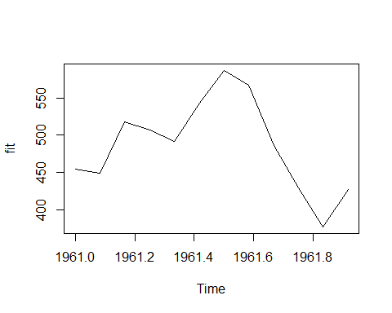

h5 <- HoltWinters(AirPassengers, alpha=0.5, beta=0.5, gamma=0.5, seasonal = "multiplicative")  
plot(h5)

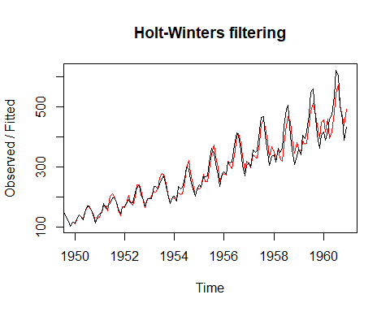

h5 <- HoltWinters(AirPassengers, alpha=0.75, beta=0.2, gamma=0.1, seasonal = "multiplicative")  
plot(h5)

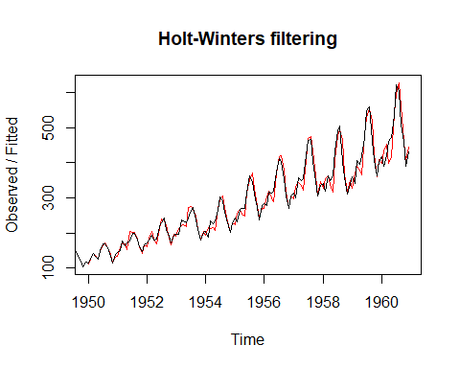

h6 <- HoltWinters(AirPassengers, alpha=0.1, beta=0.5, gamma=0.8, seasonal = "multiplicative")  
plot(h6)

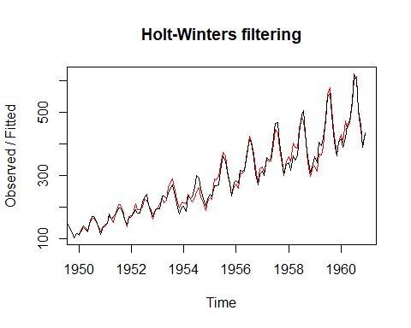

m1 <- auto.arima(AirPassengers)  
confint(m1)

## 2.5 % 97.5 %  
## ar1 0.42190083 0.7700606  
## ar2 0.04186402 0.3866851  
## ma1 -1.03911157 -0.9246429

tsdiag(m1)

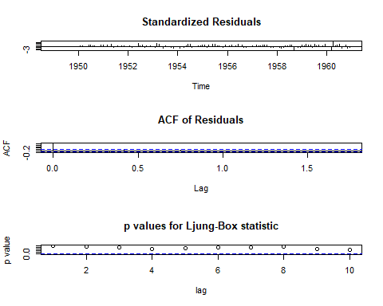

data("CO2")  
m <- stl(co2, s.window = 12)  
plot(m)

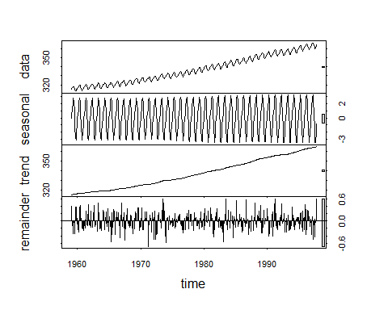

m2 <- auto.arima(co2)  
confint(m2)

## 2.5 % 97.5 %  
## ar1 -0.01864467 0.5324457  
## ma1 -0.82060727 -0.3488421  
## sar1 -1.70122774 0.6033431  
## sma1 -1.37931560 0.8552593  
## sma2 -1.45673544 0.4321064

tsdiag(m2)

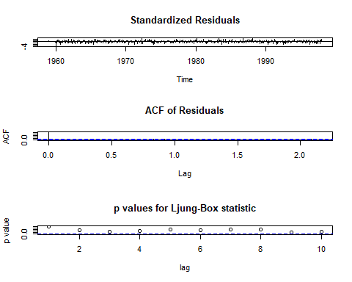

# comparing two models, HoltWinters and ARIMA   
ph <- predict(h6, n.ahead = 12)  
pa <- predict(m1, n.ahead = 12)  
plot(pa$pred)  
lines(ph, lty="dashed")

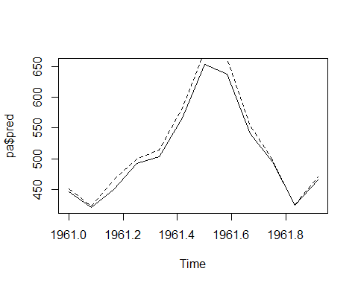

########################################################################  
# time series of the number of births per month in New York city is seasonal   
#with a peak every summer and trough every winter  
  
births <- scan("http://robjhyndman.com/tsdldata/data/nybirths.dat")  
View(births)  
  
# To make time series dataset  
birthstimeseries <- ts(births, frequency=12, start=c(1946,1))  
start(birthstimeseries)

## [1] 1946 1

end(birthstimeseries)

## [1] 1959 12

frequency(birthstimeseries)

## [1] 12

class(birthstimeseries)

## [1] "ts"

cycle(birthstimeseries)

## Jan Feb Mar Apr May Jun Jul Aug Sep Oct Nov Dec  
## 1946 1 2 3 4 5 6 7 8 9 10 11 12  
## 1947 1 2 3 4 5 6 7 8 9 10 11 12  
## 1948 1 2 3 4 5 6 7 8 9 10 11 12  
## 1949 1 2 3 4 5 6 7 8 9 10 11 12  
## 1950 1 2 3 4 5 6 7 8 9 10 11 12  
## 1951 1 2 3 4 5 6 7 8 9 10 11 12  
## 1952 1 2 3 4 5 6 7 8 9 10 11 12  
## 1953 1 2 3 4 5 6 7 8 9 10 11 12  
## 1954 1 2 3 4 5 6 7 8 9 10 11 12  
## 1955 1 2 3 4 5 6 7 8 9 10 11 12  
## 1956 1 2 3 4 5 6 7 8 9 10 11 12  
## 1957 1 2 3 4 5 6 7 8 9 10 11 12  
## 1958 1 2 3 4 5 6 7 8 9 10 11 12  
## 1959 1 2 3 4 5 6 7 8 9 10 11 12

plot(birthstimeseries)

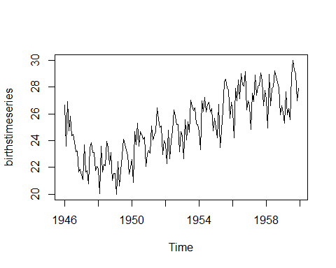

# decompose() function  
birthstimeseriescomponents <- decompose(birthstimeseries)  
birthstimeseriescomponents$seasonal

## Jan Feb Mar Apr May Jun  
## 1946 -0.6771947 -2.0829607 0.8625232 -0.8016787 0.2516514 -0.1532556  
## 1947 -0.6771947 -2.0829607 0.8625232 -0.8016787 0.2516514 -0.1532556  
## 1948 -0.6771947 -2.0829607 0.8625232 -0.8016787 0.2516514 -0.1532556  
## 1949 -0.6771947 -2.0829607 0.8625232 -0.8016787 0.2516514 -0.1532556  
## 1950 -0.6771947 -2.0829607 0.8625232 -0.8016787 0.2516514 -0.1532556  
## 1951 -0.6771947 -2.0829607 0.8625232 -0.8016787 0.2516514 -0.1532556  
## 1952 -0.6771947 -2.0829607 0.8625232 -0.8016787 0.2516514 -0.1532556  
## 1953 -0.6771947 -2.0829607 0.8625232 -0.8016787 0.2516514 -0.1532556  
## 1954 -0.6771947 -2.0829607 0.8625232 -0.8016787 0.2516514 -0.1532556  
## 1955 -0.6771947 -2.0829607 0.8625232 -0.8016787 0.2516514 -0.1532556  
## 1956 -0.6771947 -2.0829607 0.8625232 -0.8016787 0.2516514 -0.1532556  
## 1957 -0.6771947 -2.0829607 0.8625232 -0.8016787 0.2516514 -0.1532556  
## 1958 -0.6771947 -2.0829607 0.8625232 -0.8016787 0.2516514 -0.1532556  
## 1959 -0.6771947 -2.0829607 0.8625232 -0.8016787 0.2516514 -0.1532556  
## Jul Aug Sep Oct Nov Dec  
## 1946 1.4560457 1.1645938 0.6916162 0.7752444 -1.1097652 -0.3768197  
## 1947 1.4560457 1.1645938 0.6916162 0.7752444 -1.1097652 -0.3768197  
## 1948 1.4560457 1.1645938 0.6916162 0.7752444 -1.1097652 -0.3768197  
## 1949 1.4560457 1.1645938 0.6916162 0.7752444 -1.1097652 -0.3768197  
## 1950 1.4560457 1.1645938 0.6916162 0.7752444 -1.1097652 -0.3768197  
## 1951 1.4560457 1.1645938 0.6916162 0.7752444 -1.1097652 -0.3768197  
## 1952 1.4560457 1.1645938 0.6916162 0.7752444 -1.1097652 -0.3768197  
## 1953 1.4560457 1.1645938 0.6916162 0.7752444 -1.1097652 -0.3768197  
## 1954 1.4560457 1.1645938 0.6916162 0.7752444 -1.1097652 -0.3768197  
## 1955 1.4560457 1.1645938 0.6916162 0.7752444 -1.1097652 -0.3768197  
## 1956 1.4560457 1.1645938 0.6916162 0.7752444 -1.1097652 -0.3768197  
## 1957 1.4560457 1.1645938 0.6916162 0.7752444 -1.1097652 -0.3768197  
## 1958 1.4560457 1.1645938 0.6916162 0.7752444 -1.1097652 -0.3768197  
## 1959 1.4560457 1.1645938 0.6916162 0.7752444 -1.1097652 -0.3768197

plot(birthstimeseriescomponents)

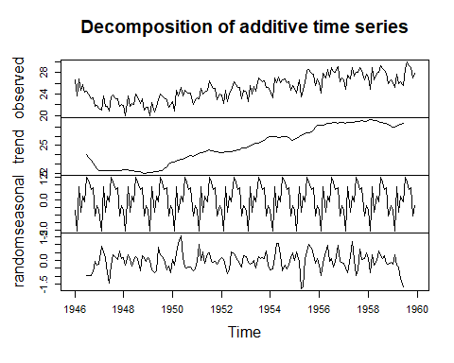

# stl function  
ts_beer = ts(birthstimeseries, frequency = 12)  
stl_beer = stl(ts_beer, "periodic")  
plot(stl_beer)

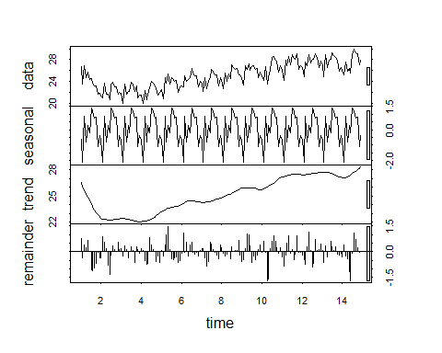

# regression line linear model  
plot(birthstimeseries)  
abline(reg = lm(birthstimeseries~time(birthstimeseries)))

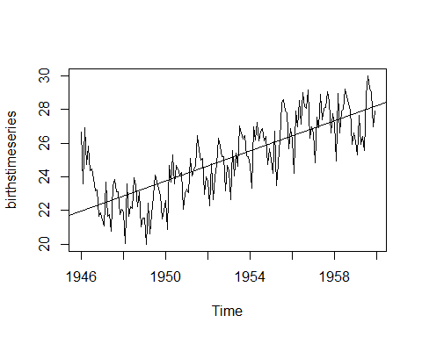

plot(aggregate(birthstimeseries, FUN = mean))

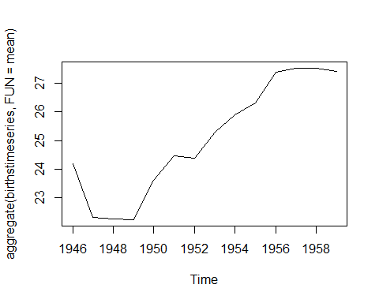

# monthly boxplot  
boxplot(birthstimeseries~cycle(birthstimeseries))

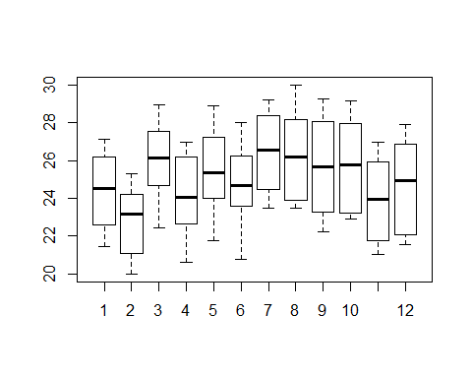

# auto corelation function, partial corelation function  
acf(log(birthstimeseries))

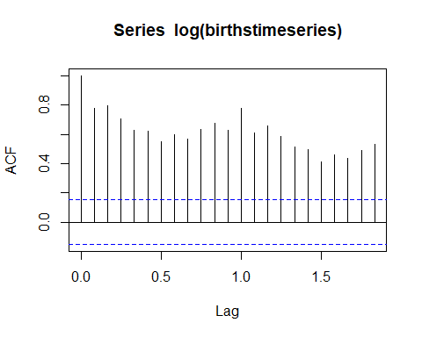

acf(diff(log(birthstimeseries)))

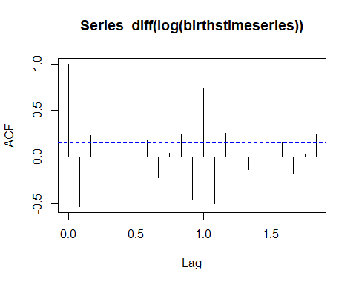

pacf(diff(log(birthstimeseries)))

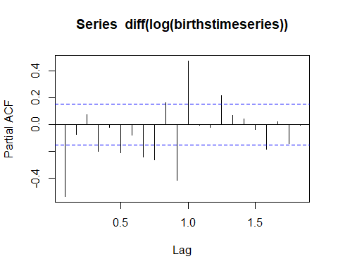

#ARIMA auto regression and moving avarage  
fit <- arima(log(birthstimeseries), c(0, 1, 1),  
 seasonal = list(order = c(0, 1, 1), period = 12))  
pred <- predict(fit, n.ahead = 10*12)  
ts.plot(birthstimeseries,2.718^pred$pred, log = "y", lty = c(1,3))

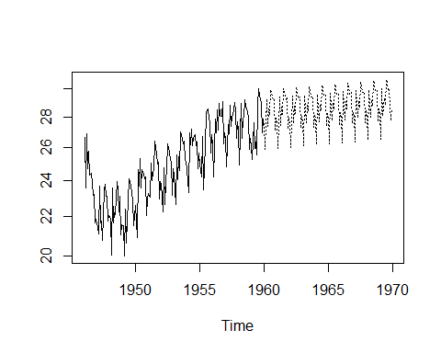

birthstimeseriesforecasts <- HoltWinters(birthstimeseries)  
birthstimeseriesforecasts

## Holt-Winters exponential smoothing with trend and additive seasonal component.  
##   
## Call:  
## HoltWinters(x = birthstimeseries)  
##   
## Smoothing parameters:  
## alpha: 0.4823655  
## beta : 0.02988495  
## gamma: 0.563186  
##   
## Coefficients:  
## [,1]  
## a 28.04366357  
## b 0.04199921  
## s1 -0.78546221  
## s2 -2.19944507  
## s3 0.87813012  
## s4 -0.65164728  
## s5 0.63427267  
## s6 0.21182821  
## s7 2.23177191  
## s8 2.17167733  
## s9 1.52077678  
## s10 1.16900861  
## s11 -0.97500043  
## s12 -0.18636055

birthstimeseriesforecasts$fitted

## xhat level trend season  
## Jan 1947 23.13579 23.81055 -0.1567618007 -0.51798958  
## Feb 1947 21.83089 22.83531 -0.1812218860 -0.82319792  
## Mar 1947 23.90724 22.29623 -0.1919165635 1.80292708  
## Apr 1947 21.58463 22.00869 -0.1947742244 -0.22928125  
## May 1947 21.51602 21.85461 -0.1935580066 -0.14503125  
## Jun 1947 20.43661 21.77488 -0.1901562399 -1.14811458  
## Jul 1947 22.44490 21.74120 -0.1854799895 0.88917708  
## Aug 1947 22.51935 22.05453 -0.1705728887 0.63538542  
## Sep 1947 22.50969 22.51328 -0.1517657072 0.14817708  
## Oct 1947 22.96787 22.64867 -0.1431840736 0.46238542  
## Nov 1947 21.63717 22.57404 -0.1411352421 -0.79573958  
## Dec 1947 22.07360 22.49168 -0.1393790022 -0.27869792  
## Jan 1948 21.19997 22.35201 -0.1393876391 -1.01264664  
## Feb 1948 21.39990 22.56814 -0.1287630591 -1.03947671  
## Mar 1948 23.37769 21.78099 -0.1484386874 1.74513652  
## Apr 1948 21.38490 21.73497 -0.1453781694 -0.20468564  
## May 1948 21.51060 21.72807 -0.1412395136 -0.07623722  
## Jun 1948 20.74546 21.92999 -0.1309843042 -1.05354663  
## Jul 1948 23.54300 22.46348 -0.1111264103 1.19064384  
## Aug 1948 23.45914 22.54868 -0.1052593374 1.01572363  
## Sep 1948 22.68217 22.46506 -0.1046127180 0.32172372  
## Oct 1948 22.53900 22.14619 -0.1110156146 0.50381900  
## Nov 1948 21.46350 22.32605 -0.1023230358 -0.76022309  
## Dec 1948 21.64158 22.02861 -0.1081540864 -0.27887258  
## Jan 1949 20.98044 21.88737 -0.1091426894 -0.79778543  
## Feb 1949 20.51366 22.05200 -0.1009610948 -1.43737755  
## Mar 1949 23.40193 21.70327 -0.1083657450 1.80702947  
## Apr 1949 20.87973 21.12318 -0.1224630574 -0.12098948  
## May 1949 20.87790 20.87302 -0.1262792355 0.13115420  
## Jun 1949 20.40721 21.17272 -0.1135488865 -0.65195982  
## Jul 1949 23.48037 22.24907 -0.0779889821 1.30929384  
## Aug 1949 23.43170 22.47189 -0.0689990677 1.02880023  
## Sep 1949 22.68327 22.55547 -0.0644393843 0.19223775  
## Oct 1949 23.39370 22.77019 -0.0560966877 0.67960929  
## Nov 1949 21.53807 22.47933 -0.0631127424 -0.87814461  
## Dec 1949 22.04476 22.40701 -0.0633876120 -0.29886513  
## Jan 1950 21.63809 22.33409 -0.0636724899 -0.63232879  
## Feb 1950 21.09947 22.73634 -0.0497484903 -1.58712202  
## Mar 1950 24.05671 22.58748 -0.0527104614 1.52193909  
## Apr 1950 22.59204 22.83398 -0.0437686872 -0.19816416  
## May 1950 23.67204 23.31162 -0.0281862050 0.38860044  
## Jun 1950 24.14110 24.07836 -0.0044300653 0.06716922  
## Jul 1950 25.28334 23.80472 -0.0124752973 1.49109716  
## Aug 1950 24.59658 23.49687 -0.0213025088 1.12101085  
## Sep 1950 23.74439 23.40679 -0.0233578809 0.36095236  
## Oct 1950 24.08539 23.56558 -0.0179144329 0.53772340  
## Nov 1950 22.72882 23.62803 -0.0155126980 -0.88370330  
## Dec 1950 22.97205 23.30148 -0.0248080600 -0.30462622  
## Jan 1951 22.91054 23.28582 -0.0245348767 -0.35074332  
## Feb 1951 21.77674 23.44287 -0.0191080068 -1.64702205  
## Mar 1951 25.73946 24.03746 -0.0007678348 1.70276886  
## Apr 1951 23.82329 23.71666 -0.0103319146 0.11696086  
## May 1951 24.67119 23.80942 -0.0072511778 0.86902159  
## Jun 1951 23.57957 23.68582 -0.0107279825 -0.09552975  
## Jul 1951 25.51717 24.19964 0.0049478806 1.31258419  
## Aug 1951 25.75289 24.65503 0.0184094962 1.07944500  
## Sep 1951 25.09588 24.60838 0.0164650350 0.47103538  
## Oct 1951 25.18693 24.58535 0.0152847303 0.58629375  
## Nov 1951 23.50602 24.56353 0.0141758088 -1.07168370  
## Dec 1951 24.02351 24.31625 0.0063623670 -0.29910163  
## Jan 1952 24.06686 24.30211 0.0057495433 -0.24099556  
## Feb 1952 22.90391 24.17817 0.0018737848 -1.27612819  
## Mar 1952 25.37635 23.87426 -0.0072643681 1.50935418  
## Apr 1952 23.74026 23.57693 -0.0159331572 0.17926269  
## May 1952 23.80016 23.03316 -0.0317073795 0.79871006  
## Jun 1952 23.28454 23.09206 -0.0289996476 0.22148371  
## Jul 1952 25.34043 23.76368 -0.0080618116 1.58481886  
## Aug 1952 25.25245 24.20690 0.0054248405 1.04012210  
## Sep 1952 24.94488 24.48416 0.0135487385 0.44716604  
## Oct 1952 25.20684 24.62560 0.0173706022 0.56386800  
## Nov 1952 23.42675 24.63919 0.0172576413 -1.22969517  
## Dec 1952 24.23069 24.52874 0.0134411353 -0.31149478  
## Jan 1953 24.47287 24.77194 0.0203074314 -0.31937515  
## Feb 1953 23.29754 24.73973 0.0187380145 -1.46092934  
## Mar 1953 25.78659 24.44322 0.0093169443 1.33404499  
## Apr 1953 24.21204 24.34566 0.0061226848 -0.13973989  
## May 1953 25.13683 24.27940 0.0039598150 0.85346860  
## Jun 1953 25.07837 24.42526 0.0082003678 0.64491022  
## Jul 1953 26.07896 24.21959 0.0018089646 1.85755984  
## Aug 1953 25.88965 24.67002 0.0152158893 1.20441194  
## Sep 1953 25.58078 25.03078 0.0255424312 0.52445571  
## Oct 1953 25.98485 25.38781 0.0354490591 0.56158359  
## Nov 1953 24.38888 25.65343 0.0423274418 -1.30687649  
## Dec 1953 25.99125 26.10920 0.0546832789 -0.17263746  
## Jan 1954 25.46444 25.77257 0.0429887904 -0.35111351  
## Feb 1954 23.80597 25.42607 0.0313491415 -1.65145193  
## Mar 1954 26.50885 25.21529 0.0241130038 1.26944738  
## Apr 1954 25.31509 25.46763 0.0309336920 -0.18347968  
## May 1954 26.90784 25.92494 0.0436757055 0.93922543  
## Jun 1954 26.67805 26.11436 0.0480315233 0.51565667  
## Jul 1954 28.06288 25.89418 0.0400157587 2.12868849  
## Aug 1954 26.71338 25.27968 0.0204556986 1.41324592  
## Sep 1954 26.12717 25.37954 0.0228287611 0.72479775  
## Oct 1954 26.13822 25.41435 0.0231867253 0.70068534  
## Nov 1954 24.52333 25.55368 0.0266576761 -1.05700401  
## Dec 1954 25.29159 25.67134 0.0293774065 -0.40913547  
## Jan 1955 25.34053 25.89194 0.0350919130 -0.58650249  
## Feb 1955 23.99020 25.75795 0.0300389027 -1.79778857  
## Mar 1955 27.34901 25.90800 0.0336255059 1.40738237  
## Apr 1955 25.73747 25.63870 0.0245724784 0.07420246  
## May 1955 25.59120 24.57193 -0.0080421066 1.02731327  
## Jun 1955 24.49995 24.16632 -0.0199233622 0.35355362  
## Jul 1955 26.71359 24.97561 0.0048575211 1.73312479  
## Aug 1955 27.26496 25.77512 0.0286057075 1.46123643  
## Sep 1955 27.22709 26.44722 0.0478365034 0.73203687  
## Oct 1955 27.65501 26.82640 0.0577385980 0.77087848  
## Nov 1955 26.00395 26.94635 0.0595980033 -1.00200282  
## Dec 1955 26.61751 26.85596 0.0551155314 -0.29357082  
## Jan 1956 26.40840 27.03818 0.0589139317 -0.68868968  
## Feb 1956 25.33566 27.00477 0.0561547942 -1.72525658  
## Mar 1956 27.78614 26.52180 0.0400431456 1.22430271  
## Apr 1956 26.08004 26.62351 0.0418862542 -0.58536330  
## May 1956 27.93893 27.09710 0.0547875612 0.78703827  
## Jun 1956 28.35352 27.43555 0.0632649298 0.85469819  
## Jul 1956 29.17212 26.91298 0.0457570914 2.21338510  
## Aug 1956 28.76019 26.86703 0.0430164218 1.85014141  
## Sep 1956 27.59166 26.62488 0.0344942058 0.93228724  
## Oct 1956 27.73302 26.88335 0.0411879146 0.80848129  
## Nov 1956 26.57005 27.60129 0.0614124953 -1.09265199  
## Dec 1956 27.36873 27.52810 0.0573898623 -0.21675566  
## Jan 1957 26.70875 27.40135 0.0518870166 -0.74448780  
## Feb 1957 25.39455 27.39548 0.0501607281 -2.05108295  
## Mar 1957 28.48586 27.18200 0.0422819008 1.26157596  
## Apr 1957 26.47371 26.76948 0.0286901907 -0.32445977  
## May 1957 27.99512 27.00187 0.0347777126 0.95847636  
## Jun 1957 28.01066 27.46252 0.0475048213 0.50063663  
## Jul 1957 29.40715 27.21064 0.0385577620 2.15796045  
## Aug 1957 28.29879 26.60179 0.0192099671 1.67779637  
## Sep 1957 27.62947 26.54488 0.0169353277 1.06765432  
## Oct 1957 28.50093 27.24607 0.0373840821 1.21748361  
## Nov 1957 26.13842 27.27528 0.0371399679 -1.17400182  
## Dec 1957 27.26772 27.55147 0.0442839832 -0.32803988  
## Jan 1958 27.09278 27.82116 0.0510200910 -0.77939858  
## Feb 1958 25.73227 27.89110 0.0515854734 -2.21041672  
## Mar 1958 28.57945 27.55280 0.0399339466 0.98671039  
## Apr 1958 27.62186 27.77775 0.0454630421 -0.20135163  
## May 1958 28.57143 27.32500 0.0305738671 1.21585707  
## Jun 1958 27.38769 27.04665 0.0213418113 0.31969997  
## Jul 1958 29.16468 27.36769 0.0302982619 1.76668940  
## Aug 1958 29.09204 27.42901 0.0312255063 1.63179627  
## Sep 1958 28.80721 27.29959 0.0264246263 1.48119011  
## Oct 1958 28.36518 27.13201 0.0206265839 1.21254688  
## Nov 1958 25.93499 26.94995 0.0145694775 -1.02952818  
## Dec 1958 26.77585 26.95343 0.0142379999 -0.19181536  
## Jan 1959 26.13602 26.89201 0.0119768814 -0.76796484  
## Feb 1959 24.44010 26.87503 0.0111116615 -2.44604591  
## Mar 1959 28.41601 27.29418 0.0233057207 1.09852546  
## Apr 1959 26.46276 26.95281 0.0124074859 -0.50245588  
## May 1959 27.75255 26.71836 0.0050301842 1.02915692  
## Jun 1959 26.55633 26.07000 -0.0144962780 0.50082655  
## Jul 1959 27.33398 25.57732 -0.0287868334 1.78544109  
## Aug 1959 27.81504 26.28705 -0.0067164116 1.53470793  
## Sep 1959 28.72300 27.33428 0.0247808156 1.36393612  
## Oct 1959 28.74117 27.61858 0.0325363622 1.09005383  
## Nov 1959 26.78196 27.78175 0.0364405634 -1.03623166  
## Dec 1959 27.72144 27.91951 0.0394683600 -0.23754203

plot(birthstimeseriesforecasts)

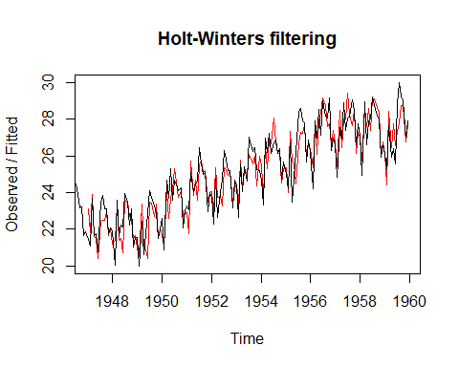

h1 <- HoltWinters(birthstimeseries, alpha="0.5", beta=0.3, gamma=0.2, seasonal = "multiplicative")  
plot(h1)

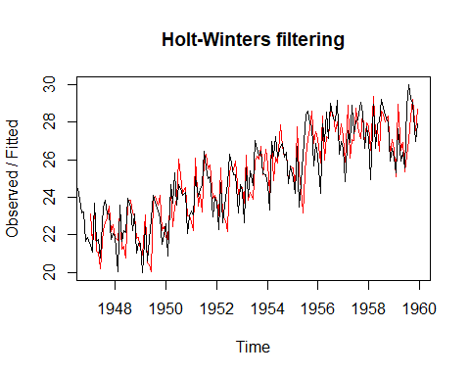

h2 <- HoltWinters(birthstimeseries, alpha="0.5", beta=0.3, gamma=0.2, seasonal = "additive")  
plot(h2)

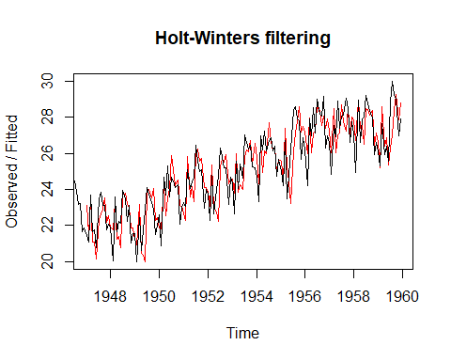

h3 <- HoltWinters(birthstimeseries, alpha="0.5", beta=0.3, gamma=NULL, seasonal = "multiplicative")  
plot(h3)

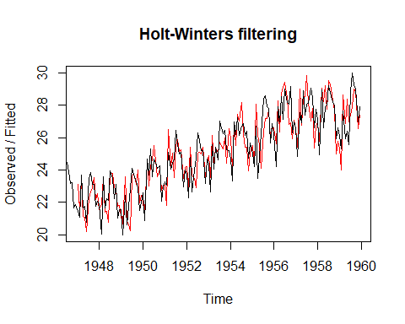

h3 <- HoltWinters(birthstimeseries, alpha="0.5", beta=0.3, gamma=NULL, seasonal = "additive")  
plot(h3)

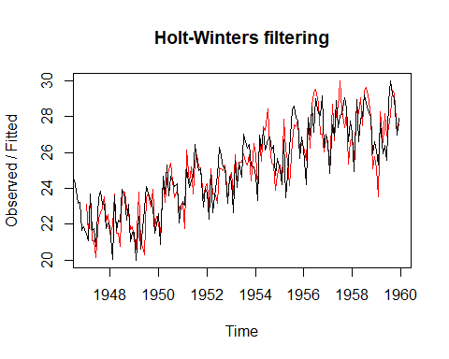

h1 <- HoltWinters(birthstimeseries, alpha="0.5", beta=NULL, gamma=NULL, seasonal = "additive")  
plot(h1)

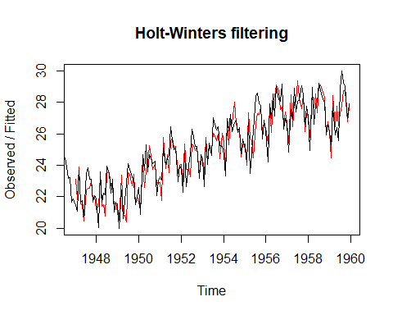

predict(h4)

## Jan  
## 1961 455.7067

predict(h4, n.ahead = 12)

## Jan Feb Mar Apr May Jun Jul  
## 1961 455.7067 439.3487 488.9996 516.4954 524.6679 582.4770 652.6906  
## Aug Sep Oct Nov Dec  
## 1961 631.9450 527.6073 473.0967 412.6361 460.1758

predict(h1, n.ahead = 12)

## Jan Feb Mar Apr May Jun Jul  
## 1960 27.30973 25.94509 29.07503 27.59975 28.93623 28.55882 30.61298  
## Aug Sep Oct Nov Dec  
## 1960 30.57737 29.95399 29.63707 27.53124 28.36080

predict(h1, n.ahead = 120)

## Jan Feb Mar Apr May Jun Jul  
## 1960 27.30973 25.94509 29.07503 27.59975 28.93623 28.55882 30.61298  
## 1961 27.80938 26.44473 29.57468 28.09939 29.43587 29.05847 31.11262  
## 1962 28.30902 26.94438 30.07432 28.59904 29.93552 29.55811 31.61226  
## 1963 28.80866 27.44402 30.57397 29.09868 30.43516 30.05776 32.11191  
## 1964 29.30831 27.94367 31.07361 29.59833 30.93481 30.55740 32.61155  
## 1965 29.80795 28.44331 31.57325 30.09797 31.43445 31.05704 33.11120  
## 1966 30.30760 28.94295 32.07290 30.59761 31.93409 31.55669 33.61084  
## 1967 30.80724 29.44260 32.57254 31.09726 32.43374 32.05633 34.11048  
## 1968 31.30688 29.94224 33.07218 31.59690 32.93338 32.55597 34.61013  
## 1969 31.80653 30.44188 33.57183 32.09655 33.43303 33.05562 35.10977  
## Aug Sep Oct Nov Dec  
## 1960 30.57737 29.95399 29.63707 27.53124 28.36080  
## 1961 31.07702 30.45364 30.13671 28.03089 28.86045  
## 1962 31.57666 30.95328 30.63636 28.53053 29.36009  
## 1963 32.07630 31.45292 31.13600 29.03017 29.85974  
## 1964 32.57595 31.95257 31.63565 29.52982 30.35938  
## 1965 33.07559 32.45221 32.13529 30.02946 30.85902  
## 1966 33.57523 32.95186 32.63493 30.52910 31.35867  
## 1967 34.07488 33.45150 33.13458 31.02875 31.85831  
## 1968 34.57452 33.95114 33.63422 31.52839 32.35796  
## 1969 35.07417 34.45079 34.13386 32.02804 32.85760

p1 <- predict(h1, n.ahead = 12)  
plot(p1)

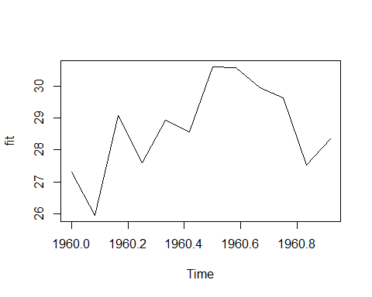

h5 <- HoltWinters(birthstimeseries, alpha=0.5, beta=0.5, gamma=0.5, seasonal = "multiplicative")  
plot(h5)

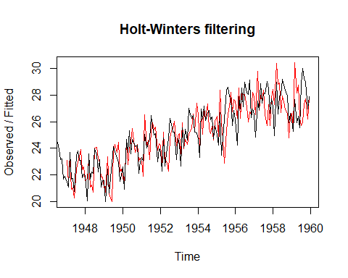

h5 <- HoltWinters(birthstimeseries, alpha=0.75, beta=0.2, gamma=0.1, seasonal = "multiplicative")  
plot(h5)

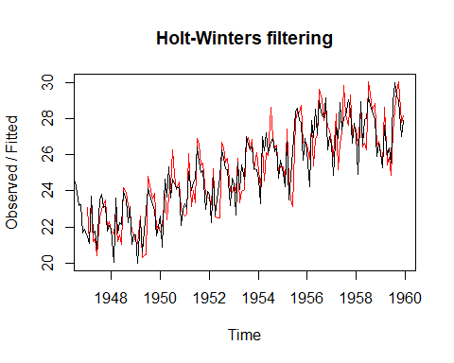

h6 <- HoltWinters(birthstimeseries, alpha=0.1, beta=0.5, gamma=0.8, seasonal = "multiplicative")  
plot(h6)

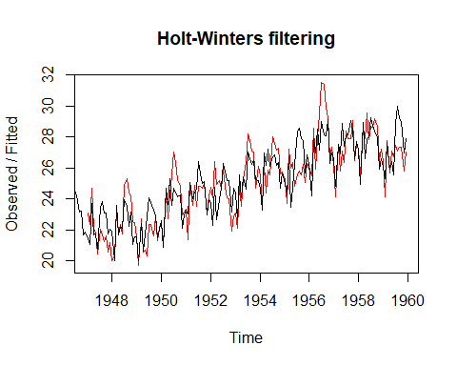

m1 <- auto.arima(birthstimeseries)  
confint(m1)

## 2.5 % 97.5 %  
## ar1 0.06514048 1.24260156  
## ar2 -0.93009076 0.02204818  
## ma1 -1.35815024 -0.09294612  
## ma2 -0.31106945 0.81745702  
## sar1 -0.43580962 -0.04963254  
## sma1 -1.04013427 -0.65012924

tsdiag(m1)

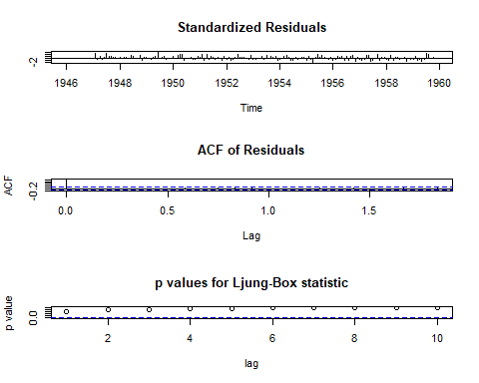

# comparing two models, HoltWinters and ARIMA   
ph <- predict(h6, n.ahead = 12)  
pa <- predict(m1, n.ahead = 12)  
plot(pa$pred)  
lines(ph, lty="dashed")

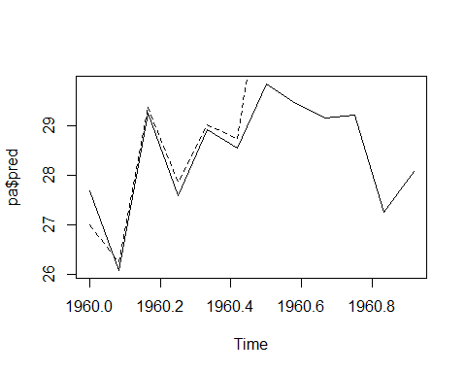

####################################################################  
library(zoo)

## Warning: package 'zoo' was built under R version 3.5.3

##   
## Attaching package: 'zoo'

## The following object is masked from 'package:timeSeries':  
##   
## time<-

## The following objects are masked from 'package:base':  
##   
## as.Date, as.Date.numeric

birthdata_zoo <- as.zoo(birthstimeseries)  
zoo_75 <- birthdata_zoo[1:126]  
zoo_25 <- birthdata_zoo[126:length(birthdata_zoo)]  
  
df_75 <- as.ts(zoo_75)  
df_25 <- as.ts(zoo_25)  
df_25

## Jan Feb Mar Apr May Jun Jul Aug Sep Oct  
## 1956 27.139 28.982 28.169 28.056 29.136  
## 1957 26.589 24.848 27.543 26.896 28.878 27.390 28.065 28.141 29.048 28.484  
## 1958 27.132 24.924 28.963 26.589 27.931 28.009 29.229 28.759 28.405 27.945  
## 1959 26.076 25.286 27.660 25.951 26.398 25.565 28.865 30.000 29.261 29.012  
## Nov Dec  
## 1956 26.291 26.987  
## 1957 26.634 27.735  
## 1958 25.912 26.619  
## 1959 26.992 27.897

birthdata_Predict <- HoltWinters(df_75, alpha = 0.485, beta = 0.001, gamma = 0.158)  
p <- predict(birthdata_Predict, n.ahead = 12)  
plot(birthdata_zoo,p)

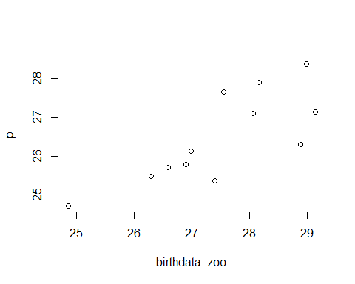

rollmean(birthstimeseries,2)

## Jan Feb Mar Apr May Jun Jul Aug  
## 1946 25.1305 25.2645 25.8355 25.2730 25.0850 24.4205 24.1890 23.5380  
## 1947 21.2640 22.3990 22.6890 21.7105 21.2565 22.1200 23.6515 23.4645  
## 1948 20.9860 21.8125 22.6310 21.9470 22.1725 23.0365 23.7270 22.8710  
## 1949 20.7740 21.2120 21.5195 21.1880 22.3175 23.4890 23.9260 23.5050  
## 1950 21.7490 22.7855 24.1750 24.4965 24.4515 24.1270 24.5625 24.2880  
## 1951 23.1680 24.0625 24.5565 24.2335 24.5485 25.5590 26.0345 25.3160  
## 1952 23.0340 23.5225 23.7105 23.3170 24.3625 25.5065 26.0460 25.5130  
## 1953 23.5040 24.1045 24.8135 24.7465 25.0330 25.8220 26.8075 26.4370  
## 1954 23.9805 25.1430 26.5905 26.7045 26.6660 26.4140 26.7920 26.5150  
## 1955 24.6145 25.4800 25.0980 24.1210 25.4930 27.2900 28.4800 28.2565  
## 1956 25.2175 26.0660 27.4445 27.7510 27.8330 28.0605 28.5755 28.1125  
## 1957 25.7185 26.1955 27.2195 27.8870 28.1340 27.7275 28.1030 28.5945  
## 1958 26.0280 26.9435 27.7760 27.2600 27.9700 28.6190 28.9940 28.5820  
## 1959 25.6810 26.4730 26.8055 26.1745 25.9815 27.2150 29.4325 29.6305  
## Sep Oct Nov Dec  
## 1946 23.2010 22.4495 21.7710 21.6545  
## 1947 23.1075 22.4345 21.9160 22.0050  
## 1948 22.6900 22.1005 21.3160 21.5605  
## 1949 23.0845 22.2130 21.7720 22.3145  
## 1950 24.1870 23.1680 22.5375 23.1390  
## 1951 25.0620 24.0370 23.4725 23.8895  
## 1952 25.2045 24.1805 23.9345 24.5355  
## 1953 26.3650 25.8540 25.2130 24.9185  
## 1954 26.2655 25.5455 25.2000 25.3390  
## 1955 27.8490 26.7385 26.2870 26.5490  
## 1956 28.5960 27.7135 26.6390 26.7880  
## 1957 28.7660 27.5590 27.1845 27.4335  
## 1958 28.1750 26.9285 26.2655 26.3475  
## 1959 29.1365 28.0020 27.4445

########################################################################